**Module 5: S3 Assignment – 2**

1. Created a S3 bucket

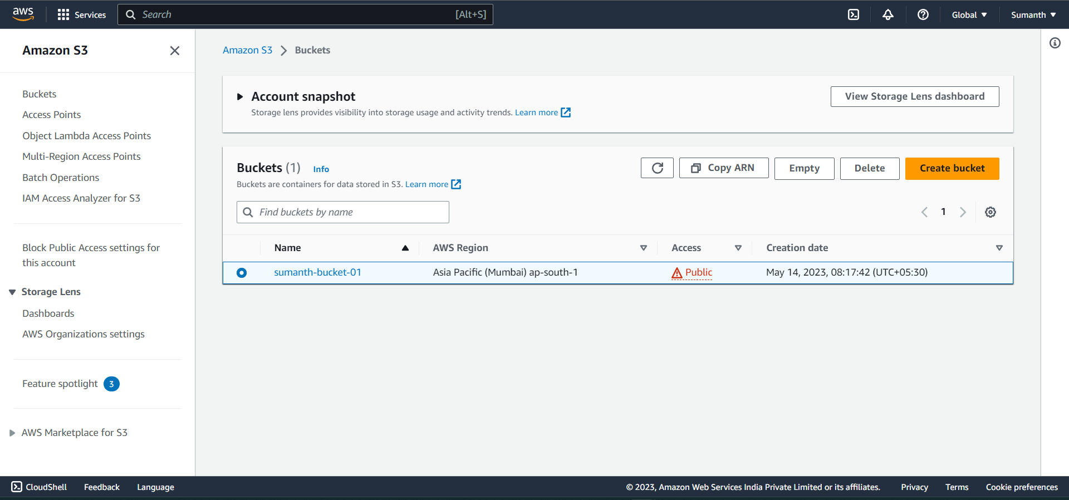

1. Uploaded the objects and enabled the versioning.

